Say the past simple of the following verbs and translate them:

INFINITIVE | PAST | TRANSLATION
GO
SAY
DO
COME
HAVE
STAND
MAKE
BUY
SIT
SWIM
SPEAK
SEE
WRITE
SING
RUN

Complete the sentences with the past simple form of the verbs in the box.

BUY CAN'T FIND HEAR GO LOSE MAKE GET MEET THINK NOT TAKE

1 He got up in the middle of the night because he heard a noise.
2 I ________ Sally at a party last week.
3 They ________ a new car two days ago.
4 We ________ to bed very late last night.
5 Karen ________ the dinner yesterday. It was pasta, as usual.
6 She was ill, so she ________ her dog for a walk this morning.
7 When we arrived in Paris, we ________ a cheap hotel near the station.
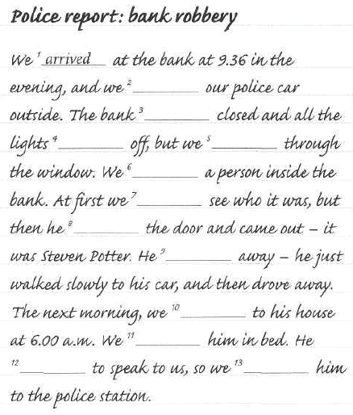
Read this police report. Complete the sentences with the past simple form of the verbs
Write your answers here:
- Arrived

BE (X2) ARRIVE LEAVE NOT WANT SEE CAN'T GO NOT RUN LOOK OPEN FIND TAKE


Can you answer these questions?
- What time did you get up yesterday?

- Where were you at 2 o'clock?

- Where did you go after lunch?

- Did you go out in the evening?

- What time did you go to bed?
Complete the questions with the correct form of the
verbs in brackets.

POLICE OFFICER Where ' were you at about 9.30 yesterday evening? (be)
STEVEN POTTER I was at the cinema. The film started at 9.00.
PO What film 2____________________ ? (see)
SP I can't remember. It wasn't very good.
PO Hmm. Very interesting. And who 3____________________ to the cinema with? (go)
SP With my girlfriend.
PO 4 ____________________ the film? (like)
SP Yes, she thought it was very good.
PO What time 5 ____________________ the film ? (finish)
SP At about 10.30.
PO And what 6 ____________________ after you left the cinema? (do)
SP We went to a restaurant - La Dolce Vita, on the High Street.
PO La Dolce Vita, I know it. Very good spaghetti. What time 7 ____________________ the restaurant? (leave)
SP At about 12.00.
PO That's very late. 8 ____________________ home after that? (go)
SP No, we went to a nightclub - Flanagan's. Then we went home.
PO How? 9 ____________________ a taxi? (get)
SP No, we got a bus.
PO And what time 10 ____________________ to bed? (go)
SP At about 4.00 a.m. Can I go home now? I'm tired.
PO No, I'd like to ask you some more questions...

