UNDERLINE THE PREPOSITION
Today is my birthday! I was born in 2005, on the 7th of July, at 2 o’clock in the morning! On my birthday I always open my presents at breakfast time. In July we always visit my grandparents and on the last day at midnight my dad lights some fireworks outside – very carefully of course!
Do you remember that we use different prepositions for different time words? Which preposition do we use with...
Months and years?
Days and dates?
Times?
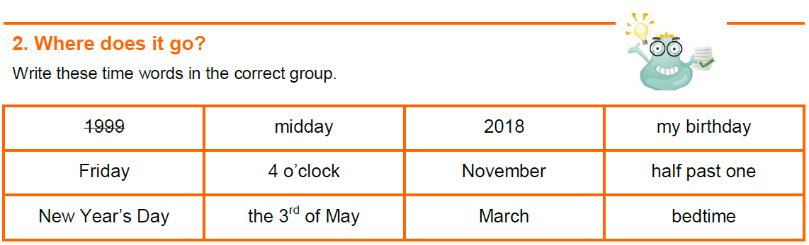

IN | ON | AT
1999

Find the mistake, underline it and write the correct word.
a. My birthday is on November.
b. His mother was born at 1957.
c. I normally wake up in 8 o’clock.
d. In Tuesdays I play tennis.
e. They read stories on bedtime.
f. At August we went to the beach.
g. At Christmas Day I love opening presents.

Send your answers to arantxamarso@gmail.com

